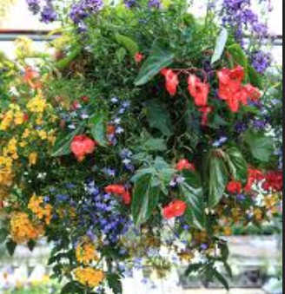
Please support programs for BURNABY SOUTH Students by participating in our
HANGING BASKET FUNDRAISER
Order now for Mother’s Day May 10th . . . .
ONLY $26 each (tax included) for 12 inch
Baskets, all plants are “proven winner” brand from Windsor Greenhouse. Same as the past few years – Go online to view www.windsorgreenhouse.ca
__________ MIXED plants such as geranium, verbena, lobelia, pansies
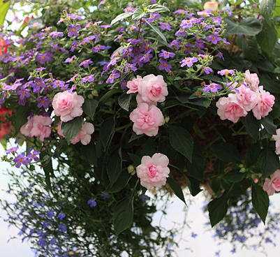
OR
_______ Fuchsias
Name:_________________________
Phone #:_________________
Email:
__________________________________ (for reminder notice)
$26.00 X ______baskets = $ _____________ amount enclosed
PRE-ORDER by April 21, return form and payment to:
Burnaby South 5455 Rumble St., Burnaby BC V5J 2B7 (cheques
Payable to: Burnaby South PAC)
----------------------------------------------------------------------------------------
Pick up baskets at Burnaby South School Parking Lot on Tuesday
May 5, between 1:30pm and 5:30pm (cut on dotted line and keep this reminder)

